**Project Development Phase**

**Model Performance Test**

|  |  |
| --- | --- |
| Date | 16 Jun 2025 |
| Team ID | LTVIP2025TMID49086 |
| Project Name | iRevolution: A Data-driven Exploration of Apple's iPhone Impact in India using Tableau. |
| Maximum Marks |  |

**Model Performance Testing:**

Project team shall fill the following information in model performance testing template.

|  |  |  |
| --- | --- | --- |
| **S.No.** | **Parameter** | **Screenshot / Values** |
|  | Data Rendered | Dataset contains iPhone sales, user demographics, and social media data (e.g., 10,000+ records).  Rendered to DB2 from CSV/Excel via Python script. |
|  | Data Preprocessing | Normalized region names  Cleaned null values  Aggregated monthly sales  Created derived fields |
| 3. | Utilization of Filters | Applied filters for:  • Region • Year • Age group • Income level • Sentiment type |
| 4. | Calculation fields Used | Created fields like:  • YOY Growth = (Current Year - Previous Year)/Previous Year • Sentiment Score Average • Penetration Rate (%) |
| 5. | Dashboard design | 8 Visualizations :  • Line chart (Sales Trend) • TreeMaps • Bar chart  • Donut chart  • Lined Bar Chart • KPI cards (Total Users, Avg Sentiment)  • Bubble chart  • Text tables |
| 6 | Story Design | 4 Scenes: • Scene 1: Intro and Problem • Scene 2: Market Trends • Scene 3: User Analysis • Scene 4: Social Impact Summary |

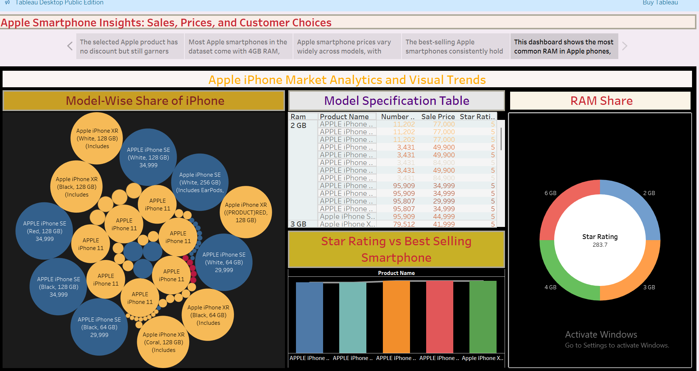

Story Visual for Apple Smartphone Insights

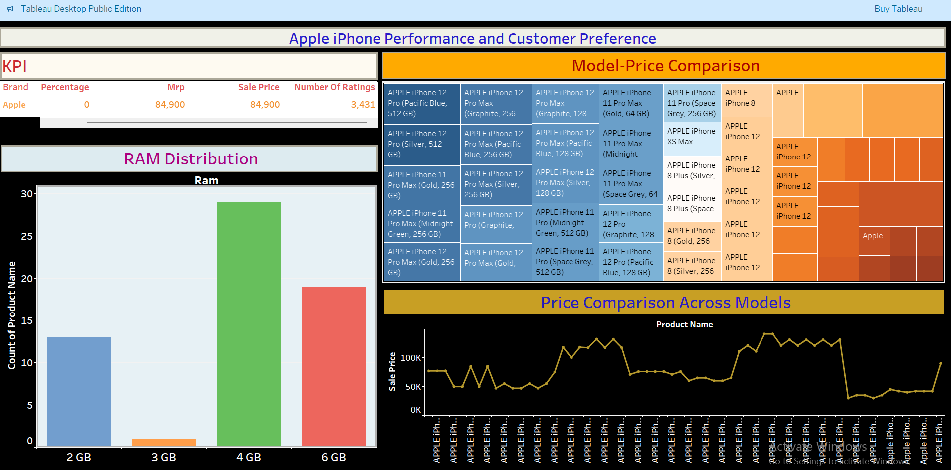

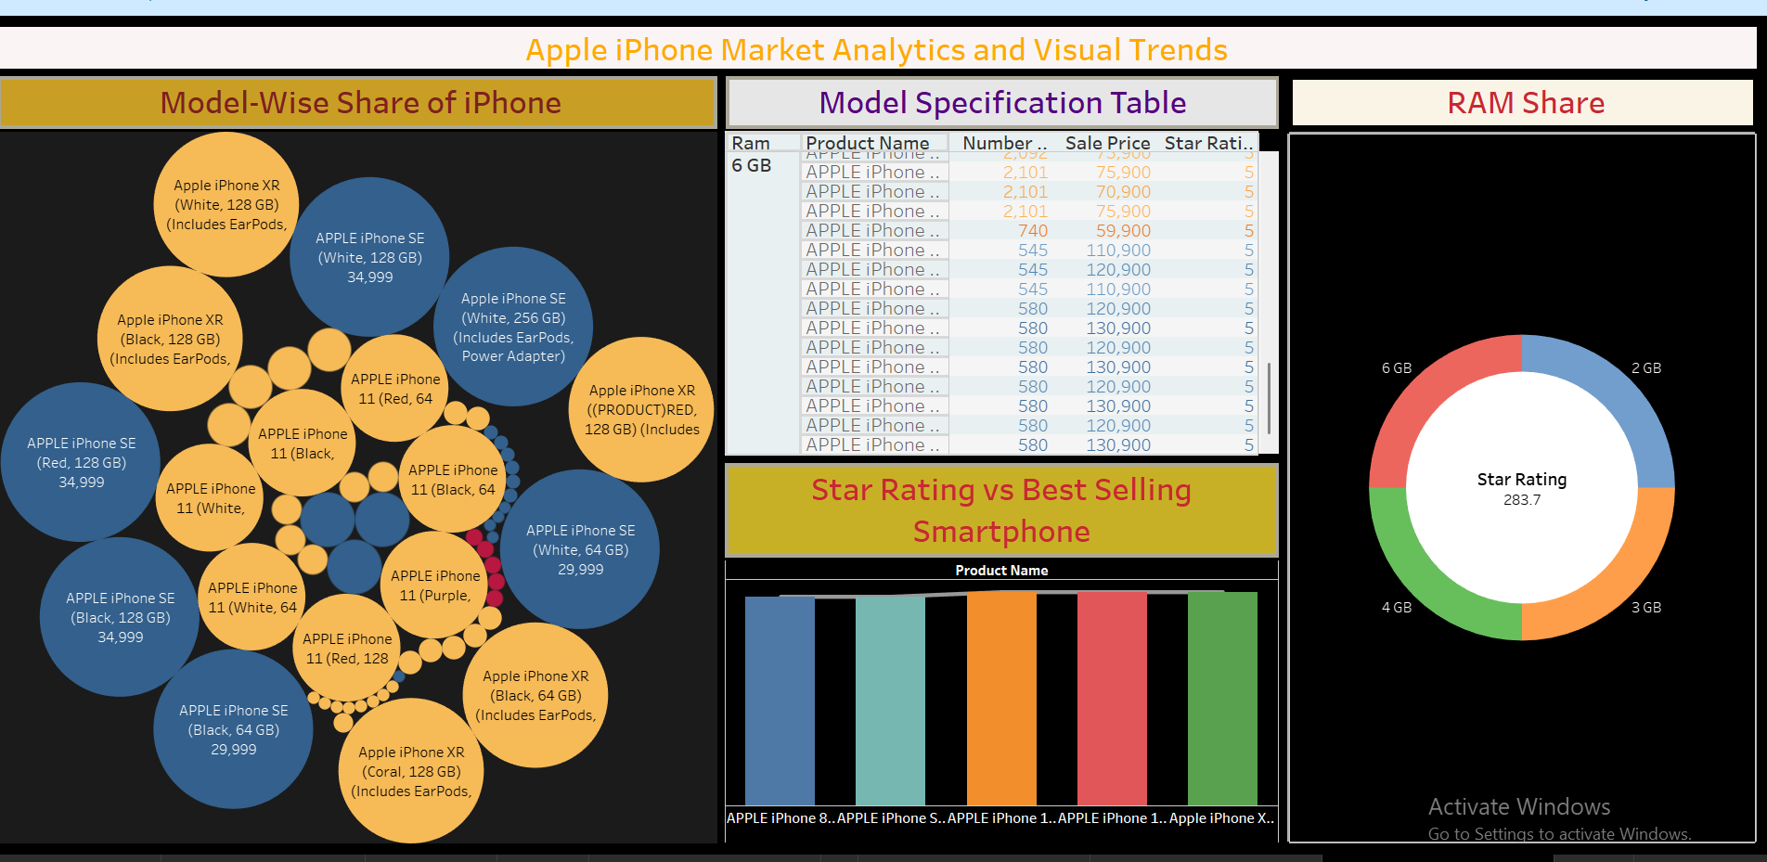

Dashboards based on the visuals used to show the trends, insights on Apple Iphone.